Task 1- Basic Logic gates & Half Adder Simulation
Digital logical fundamentals and simulation of logic gates
LOGIC GATE
AND Gate:
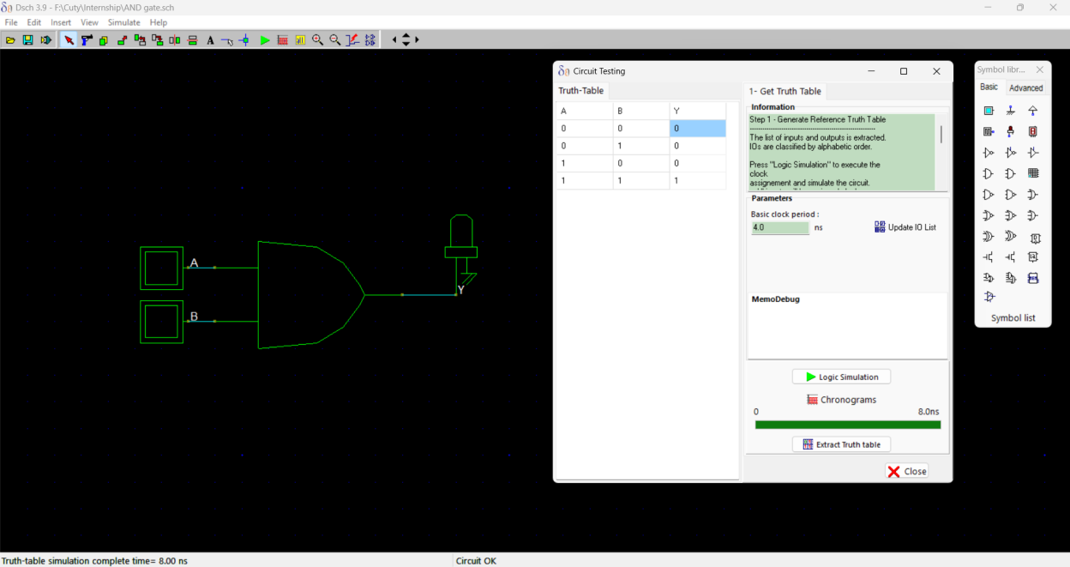

OR Gate:
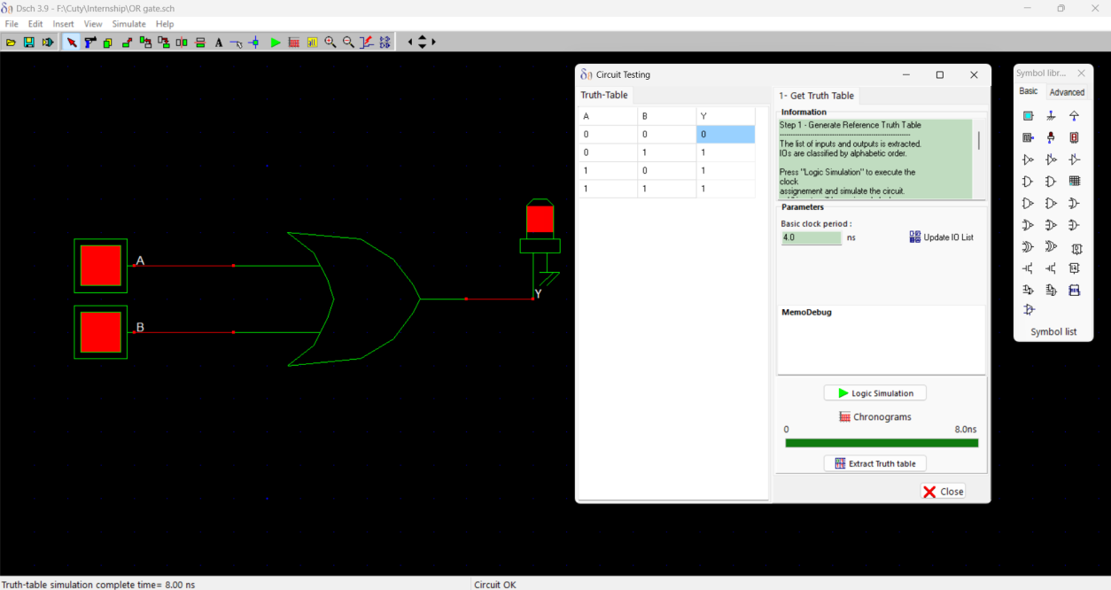

NOT Gate:
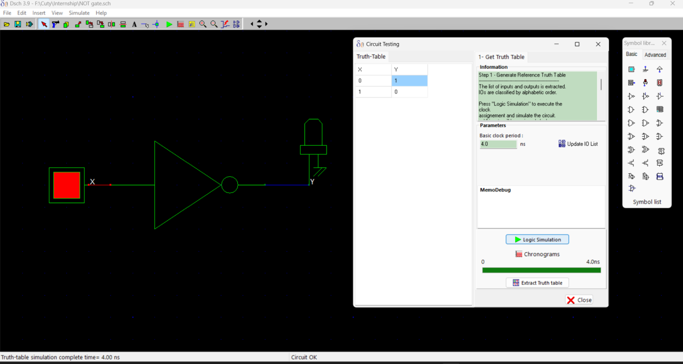

NAND Gate:
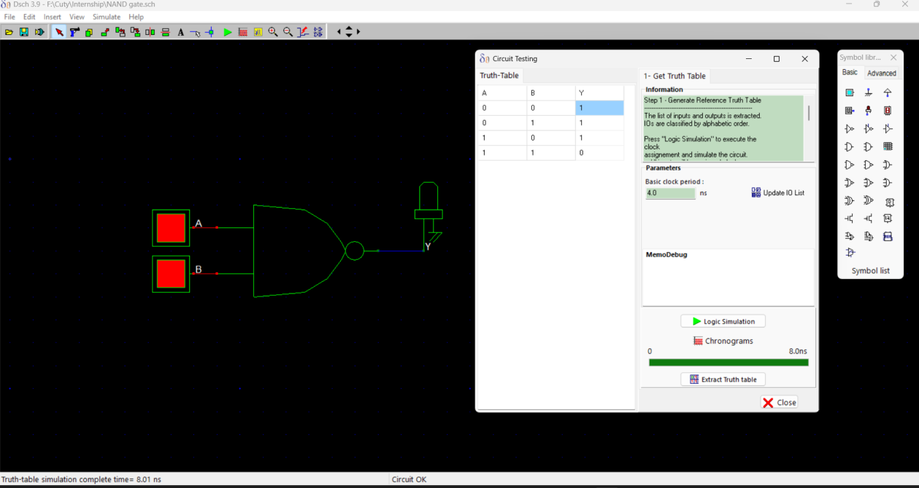

NOR Gate:
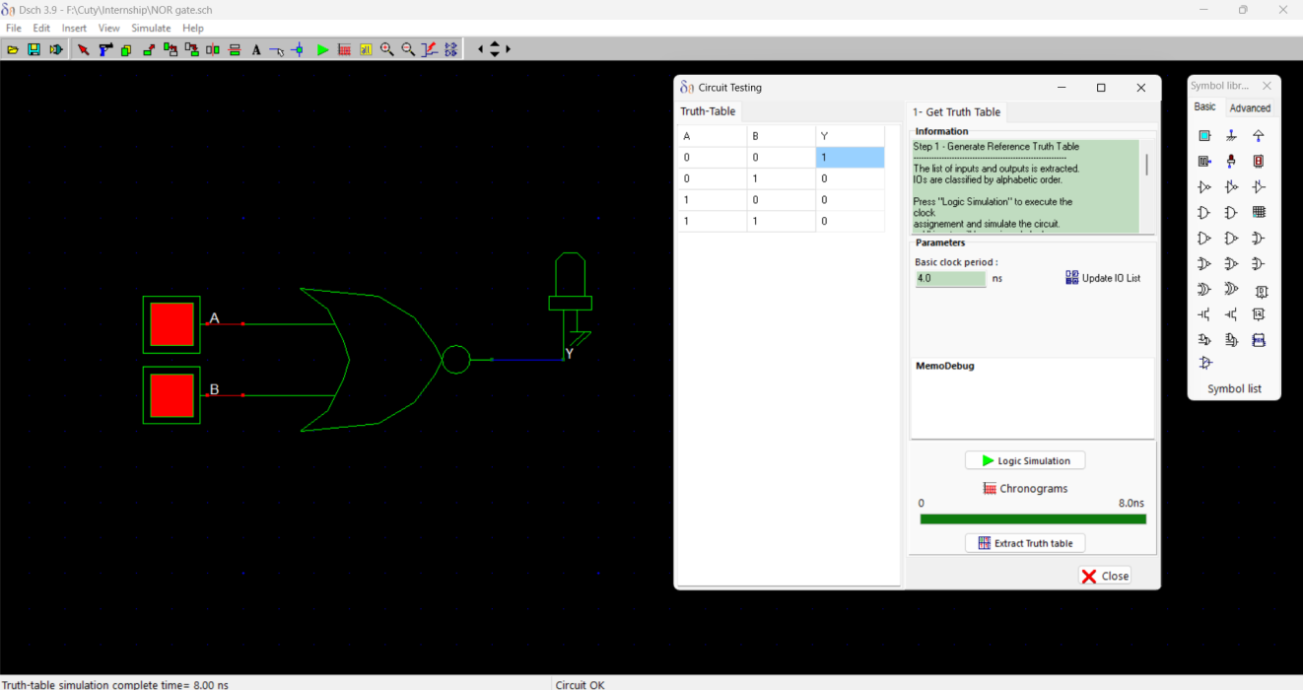

XOR Gate:
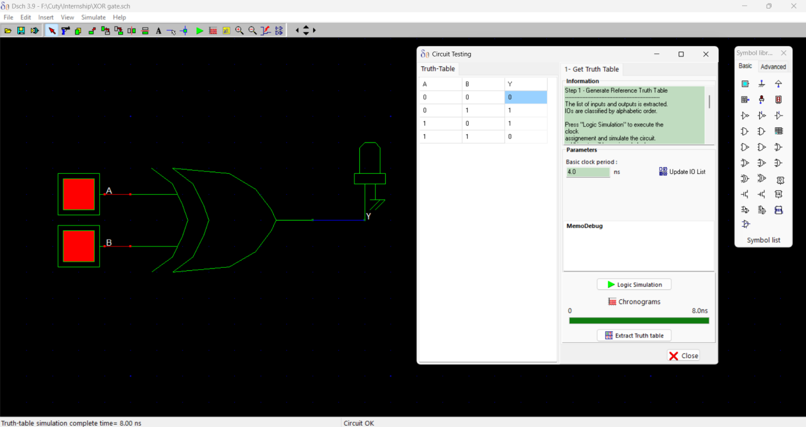

Half-Adder:
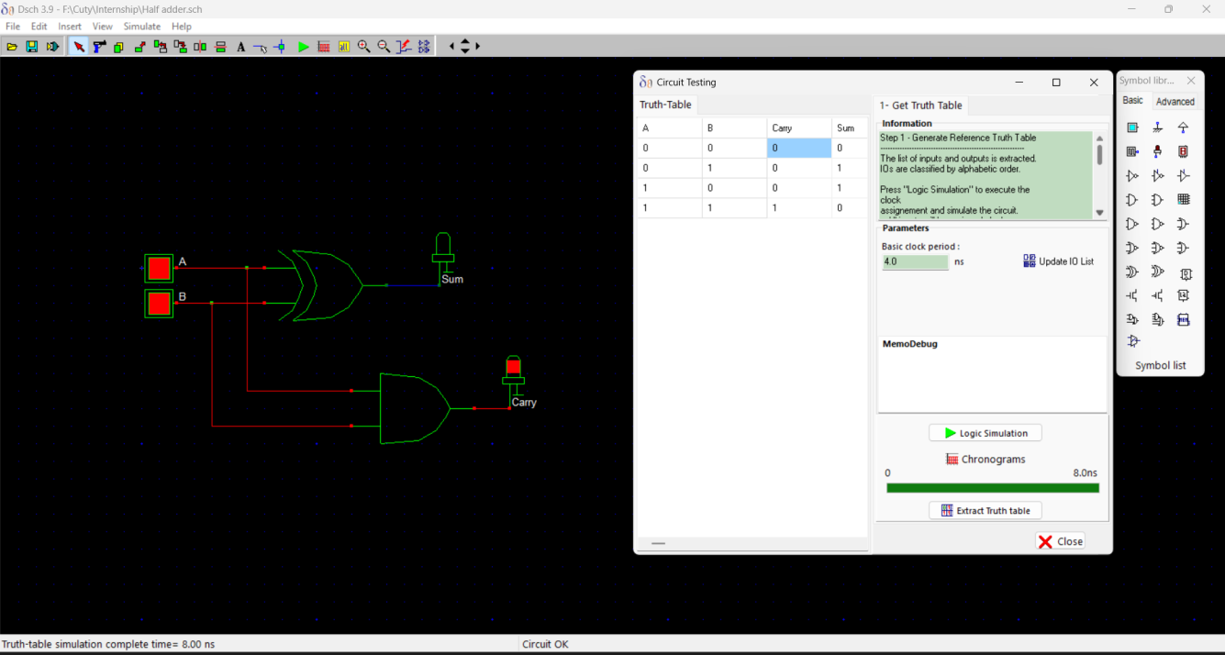
Full-Adder:
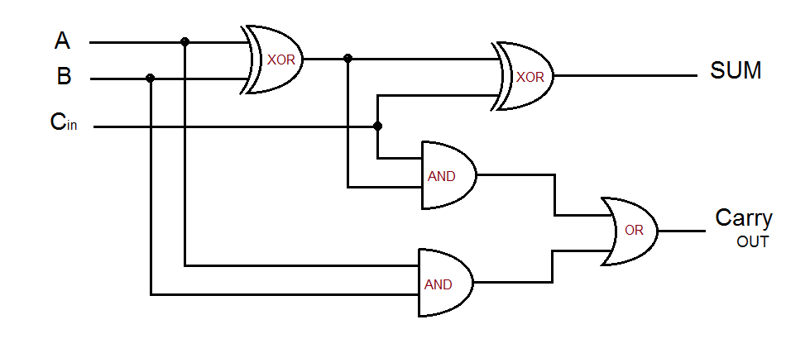

Explanation of VLSI Design Flow:
VLSI is the process of designing a chip that contains millions or even billions of transistors. Think of VLSI like building a house: first you plan VLSI then design VLSI then construct VLSI and finally test VLSI. A chip follows a flow.
1. Specification: this is the planning stage of VLSI.
Engineers decide what the chip should do what the speed requirements are, what the power consumption limits are, what the area or chip size is and what the cost targets are.
2. Architecture Design is creating the blueprint for VLSI.
Engineers divide the VLSI chip into blocks like the processor, memory, input/output units and control logic.
3. RTL Design is where engineers write the hardware behaviour using hardware description languages like Verilog, System Verilog and VHDL for VLSI.
4. Functional Verification is where engineers check whether the RTL code works correctly for VLSI. They run simulations, test inputs and find and fix bugs in VLSI.
The goal is to ensure the VLSI design behaves as expected before building the VLSI chip.
5. Synthesis is where the RTL code is converted into actual logic gates such as AND gates OR gates, NOT gates and flip-flops for VLSI.
Think of this as converting a recipe into ingredients for VLSI.
6. Floor planning is where the VLSI chip area is divided into regions.
Engineers decide where memory goes, where processing blocks go and where input/output pins are placed in VLSI. This is similar to deciding room locations in a house for VLSI.
7. Placement is where all logic cells are placed on the VLSI chip.
The software finds locations for millions of cells while considering speed, area and power for VLSI.
8. Clock Tree Synthesis is where a clock signal must reach every flip-flop at the same time for VLSI. Engineers build a clock distribution network called a clock tree for VLSI.
Think of it as distributing electricity throughout a city for VLSI.
9. Routing is where connections or wires are added between all cells for VLSI.
This creates the paths through which signals travel for VLSI. It is similar to building roads connecting houses in a city for VLSI.
10. Physical Verification is where engineers check if all design rules are followed if there are any wire overlaps and if the VLSI chip can be manufactured. Common checks include DRC or Design Rule Check and LVS or Layout Versus Schematic for VLSI.
11. Timing Analysis is where the VLSI chips speed is checked.
Engineers verify that signals arrive on time and there are no timing violations for VLSI.
This step ensures the VLSI chip can run at the target frequency.
12. Tape-Out is where the final VLSI design is sent to the semiconductor factory for manufacturing. This is called Tape-Out for VLSI. Think of it as submitting the blueprint to the builder for VLSI.
13. Fabrication is where the VLSI chip is manufactured on silicon wafers in a fabrication plant. Companies such, as TSMC, Intel Foundry and Samsung Foundry fabricate VLSI chips.
14. Testing and Packaging is where the manufactured VLSI chips are tested for defects, packaged and shipped to customers.

TRUTH TABLES:
AND Gate:
A | B | Y
0 | 0 | 0
0 | 1 | 0
1 | 0 | 0
1 | 1 | 1

OR Gate:
A | B | Y
0 | 0 | 0
0 | 1 | 1
1 | 0 | 1
1 | 1 | 1

NOT Gate:
A | Y
0 | 1
1 | 0

NAND Gate:
A | B | Y
0 | 0 | 1
0 | 1 | 1
1 | 0 | 1
1 | 1 | 0

NOR Gate:
A | B | Y
0 | 0 | 1
0 | 1 | 0
1 | 0 | 0
1 | 1 | 0

XOR Gate:
A | B | Y
0 | 0 | 0
0 | 1 | 1
1 | 0 | 1
1 | 1 | 0

Half-Adder:
A | B | Sum | Carry
0 | 0 | 0 | 0
0 | 1 | 1 | 0
1 | 0 | 1 | 0
1 | 1 | 0 | 1
Full-Adder:
A | B | Cin | Sum | Carry
0 | 0 | 0 | 0 | 0
0 | 0 | 1 | 1 | 0
0 | 1 | 0 | 1 | 0
0 | 1 | 1 | 0 | 1
1 | 0 | 0 | 1 | 0
1 | 0 | 1 | 0 | 1
1 | 1 | 0 | 0 | 1
1 | 1 | 1 | 1 | 1

Obsevations from Simulation:
The simulation results of the logic gates showed that they worked as expected. The AND gate gave an output only when both its inputs were HIGH. The OR gate gave an output when at least one of its inputs was HIGH. The NOT gate changed the input signal to its opposite. The NAND gate gave an output only when both its inputs were HIGH. The NOR gate gave an output only when both its inputs were LOW. The XOR gate gave an output when its two inputs were not the same. The Half Adder simulation added two numbers correctly. It used XOR logic to get the Sum and AND logic to get the Carry output. The Full Adder simulation also worked well. It added three inputs, A, B and Carry-in and gave the right Sum and Carry-out outputs for all possible input combinations. The outputs, from the simulations matched the expected results. All the logic gates and adders worked according to their truth tables.
Conclusion
The simulation results showed that the basic logic gates, Half Adder and Full Adder circuits all worked as they should. The results we got from these logic gates and adder circuits matched what the truth tables said they should be. This means the logic gates and adder circuits we designed were correct. So the logic gates and adder circuits were. Simulated successfully. The logic Adder circuits, like the Half Adder and Full Adder circuits all functioned as expected.

